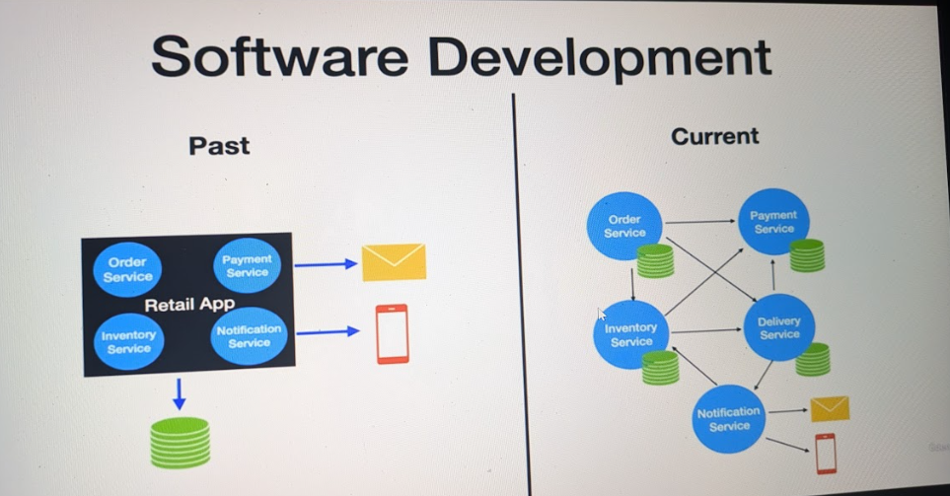
We have used rancher desktop .
Earlier the Application was stack in a single component now the application is divided into small components which can communicate with each other using rest api , or event driven communication like Apache kafka .
Now each service listen to events through Event Streaming Platform (Apache Kafka) and the application works on the principle of event-driven communication where there will be producer for sending message and there will be consumer which will listen to events
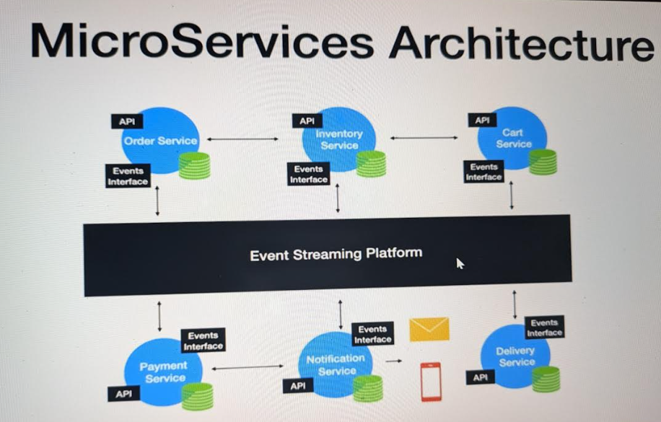
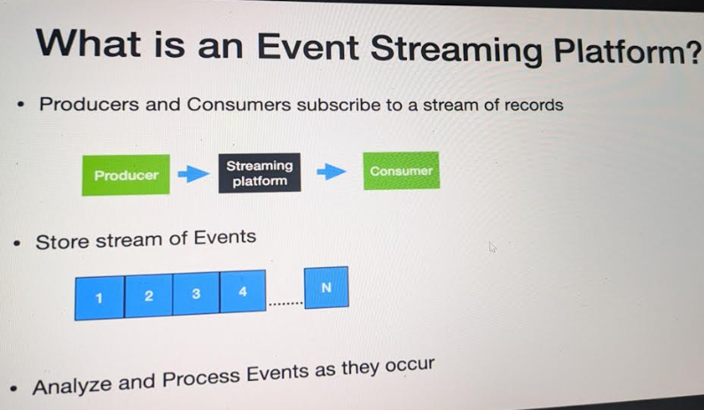
Streaming Platform will act as a broker between Producer and consumer and helps in processing of events.
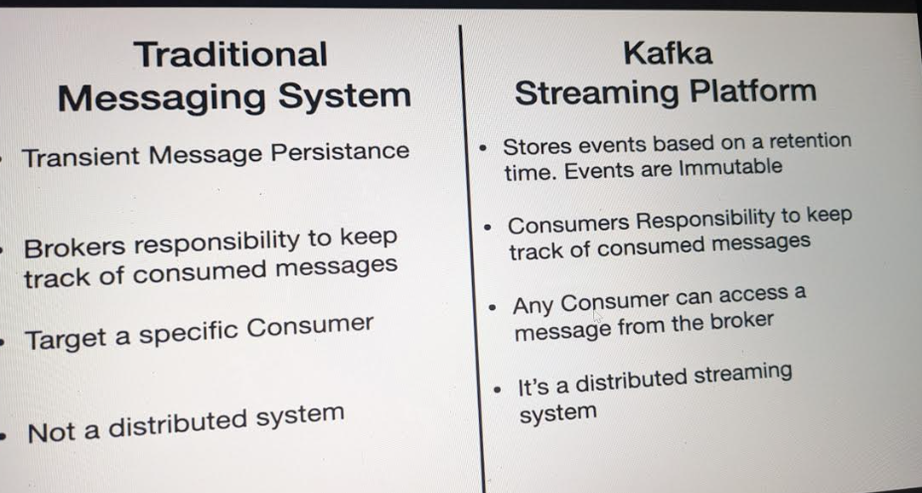
Here Transient Message Persistance means that once message is read by consumer it is lost.But Kafka store message based on the retention time . Here events are immutable.
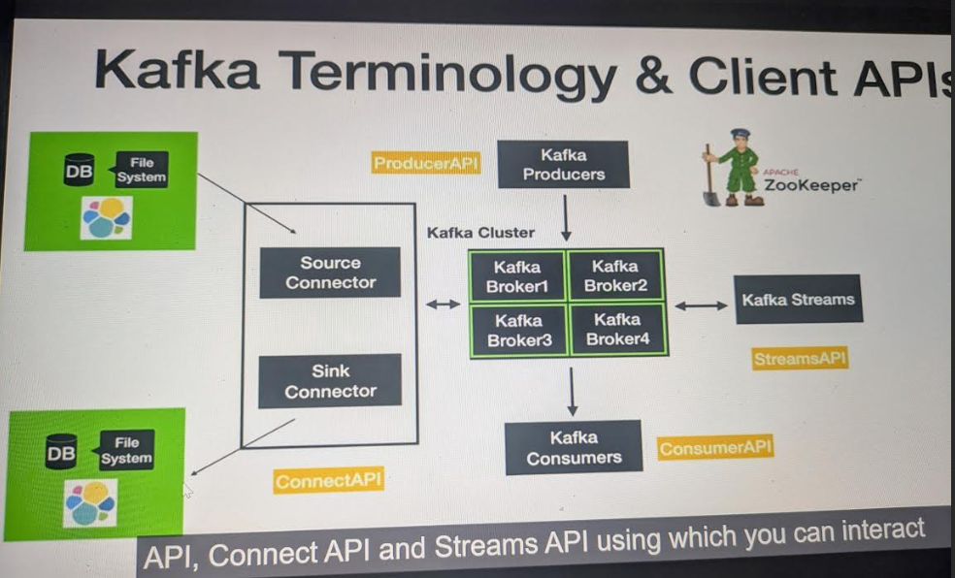
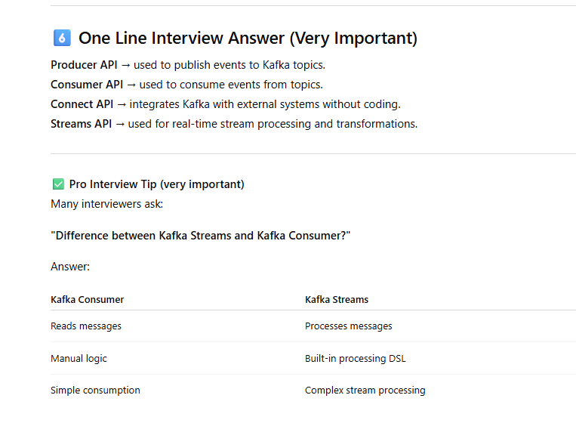
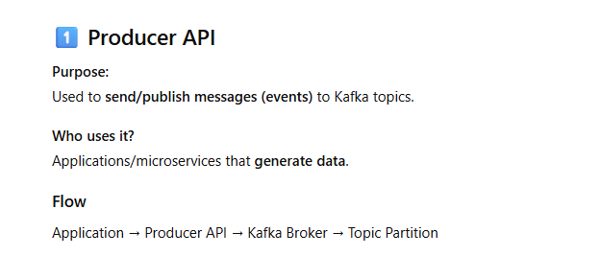
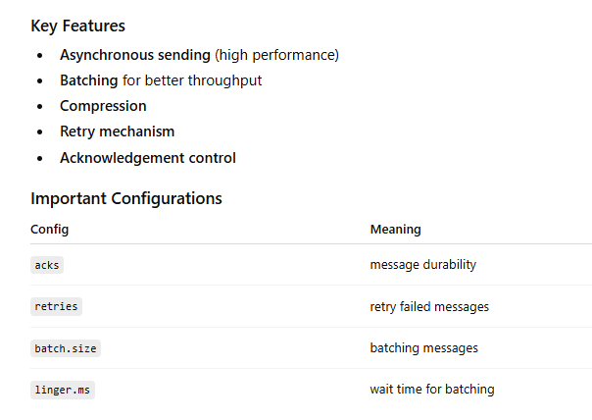
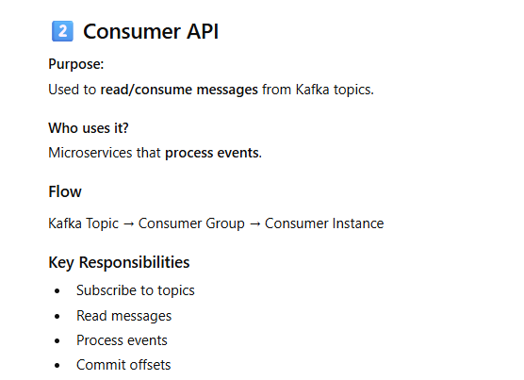
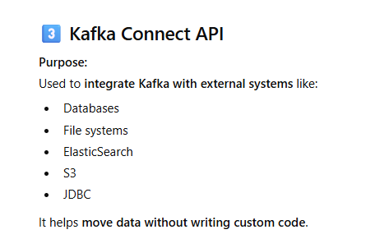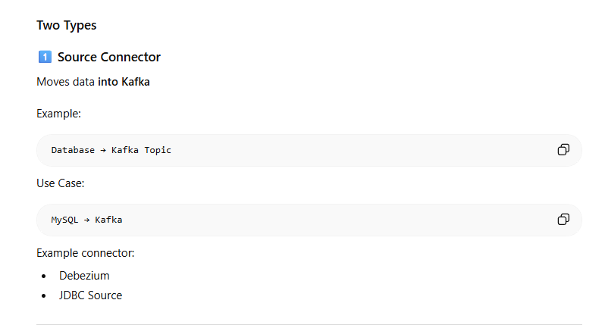
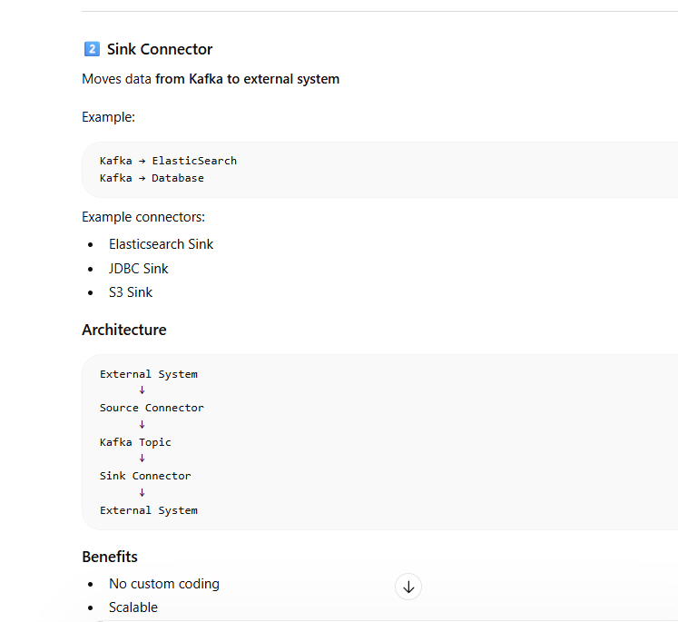
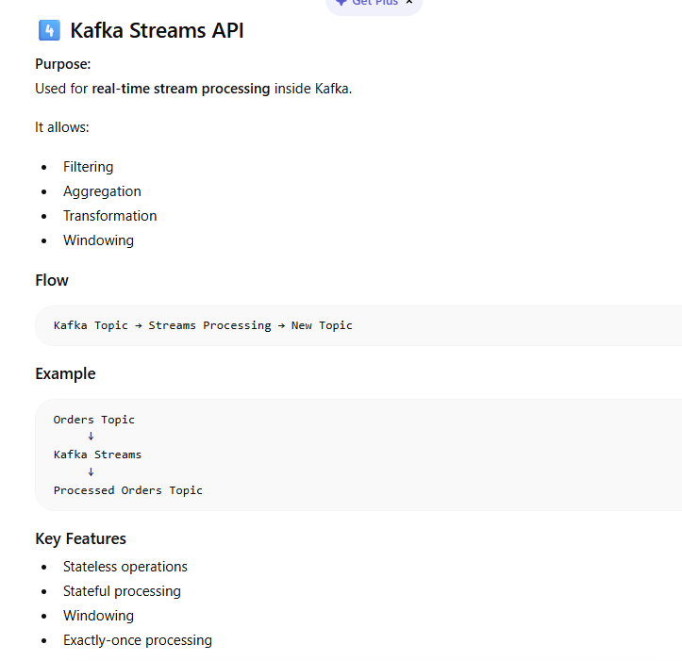
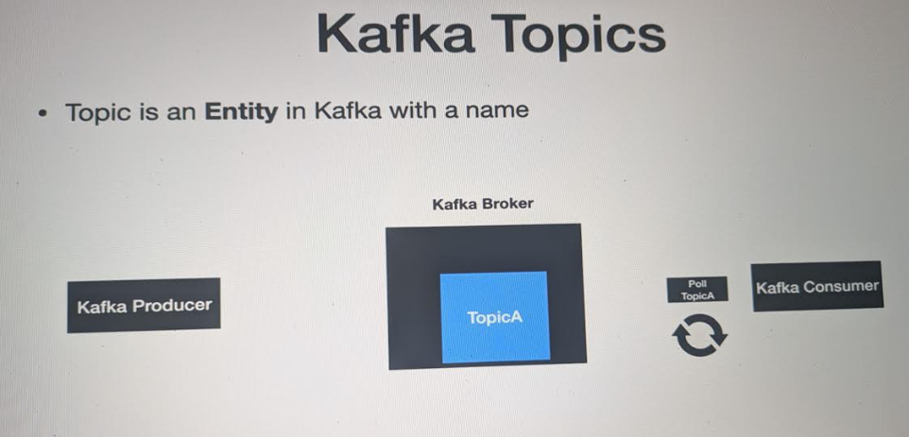
Here Topic is Like a Entity in Kafka where Producer send message according to topic and consumer pull data according to topic .
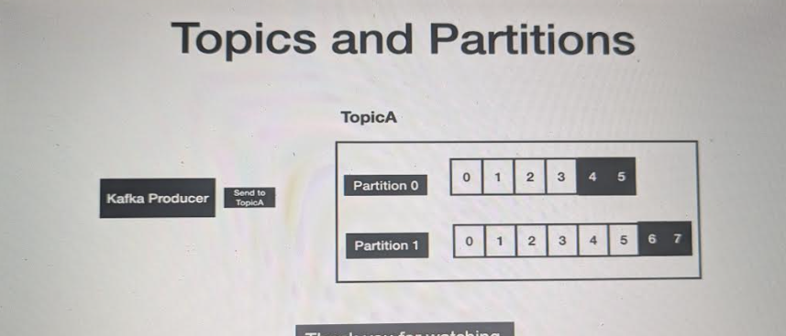
There is no set rule for Producer that how many partitions will be there but each consumer can consume only one partition .
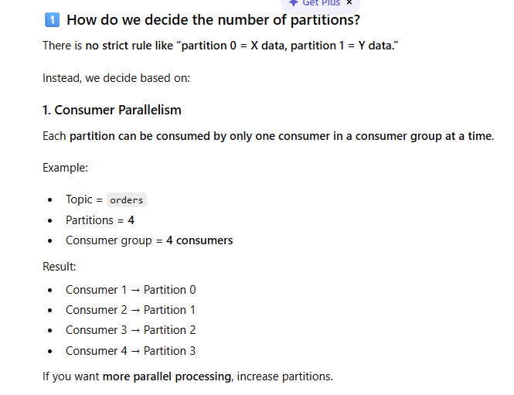
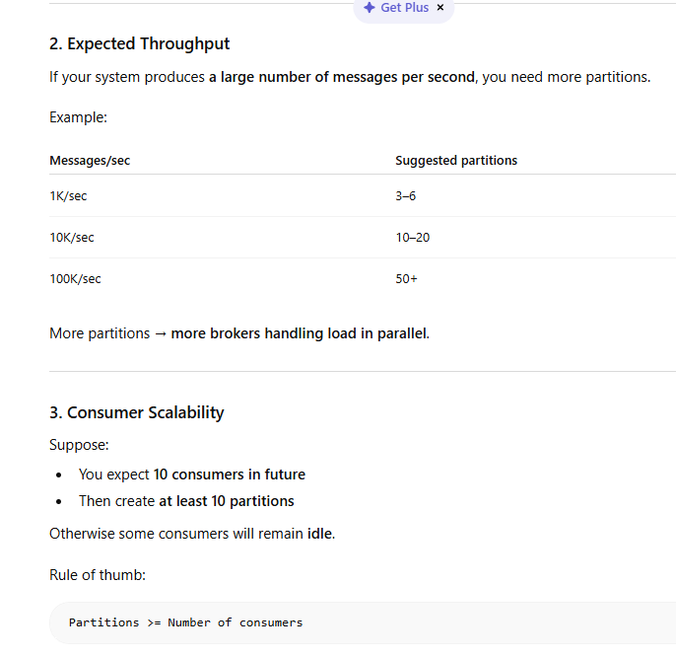
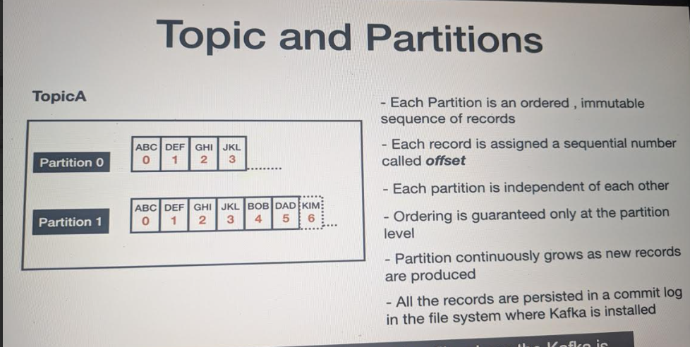
ZooKeeper : is used as centralized service maintaining configuration information , health of Kafka broker and providing synchronization when we have multiple broker which is also known as Kafka Cluster.
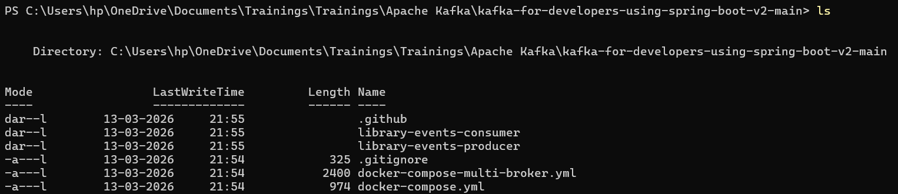
we have opened folder and then we will check on docker-compose.yml where our zookeeper and Kafka are configured .
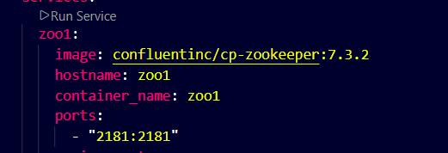
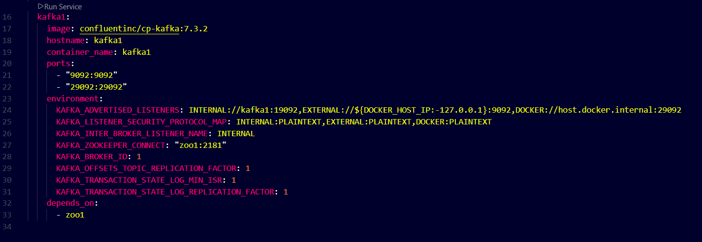
Kafka depends on zookeeper.
With this command we will start zookeeper and kafka
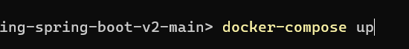
With docker ps you can check status of zookeeper and kafka
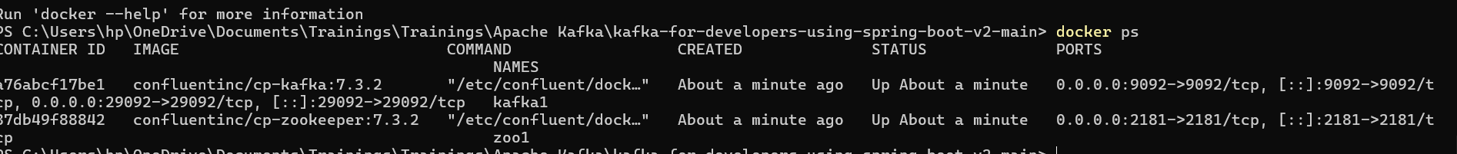
Steps to produce and consume messages ::
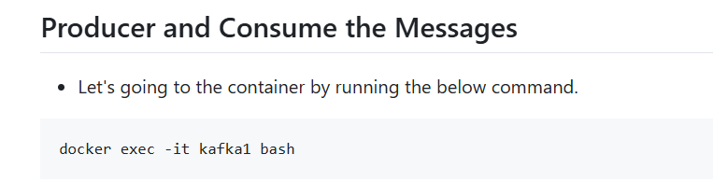
This command is for login container
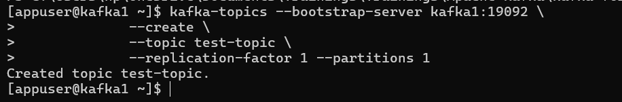
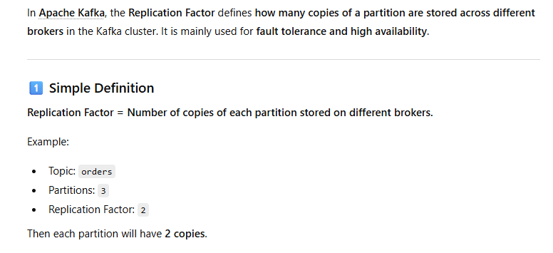
To produce meesage exit from container start fresh :
docker exec -it kafka1 kafka-console-producer --bootstrap-server localhost:9092 --topic test-topic
To consume message from container :
docker exec -it kafka1 kafka-console-consumer --bootstrap-server localhost:9092 --topic test-topic --from-beginning
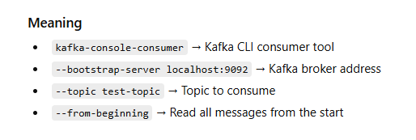
To see the list of topics ::
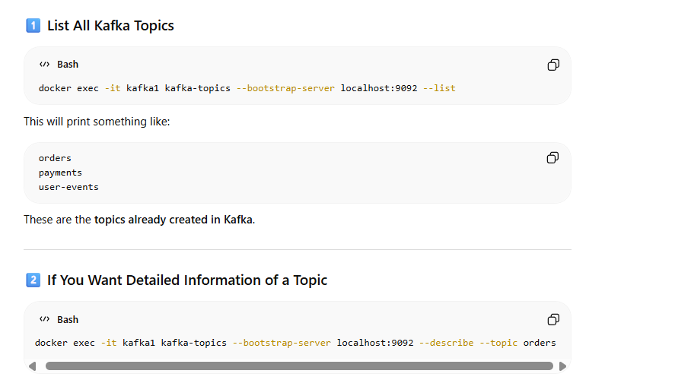
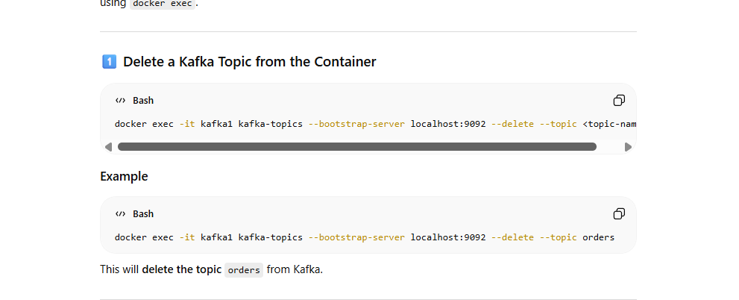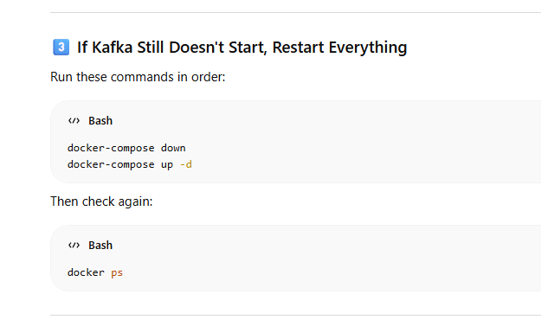
Kafka Message these sent from producer has two properties
Key(Optional)
Value
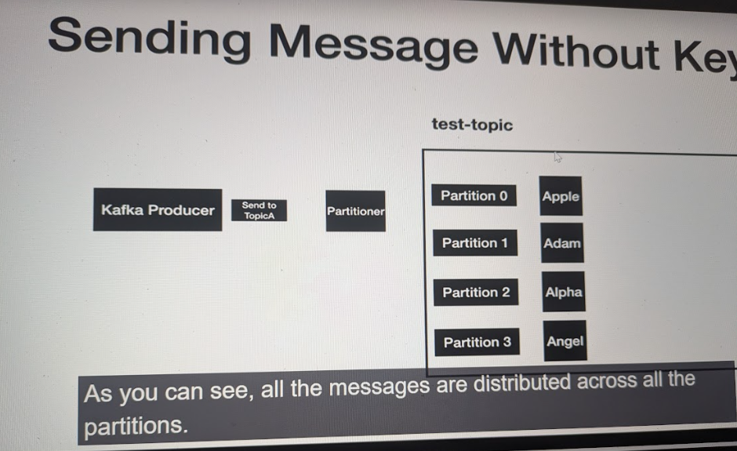
Without a key the messages are distributed across evenly into partitions using Round-Robin Algorithm
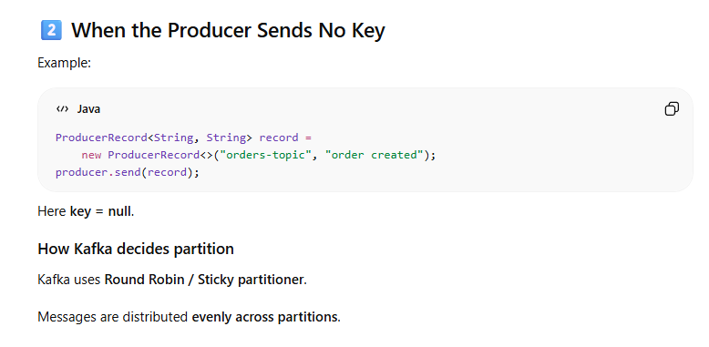
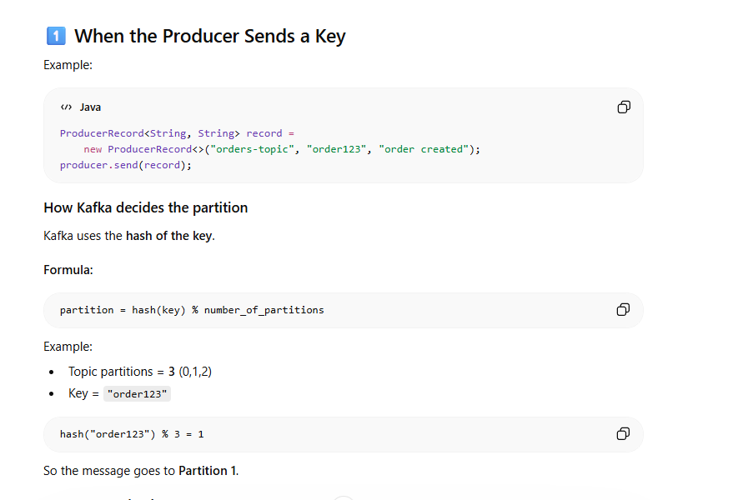
With KEY COMMAND WILL BE ::
docker exec -it kafka1 kafka-console-producer --bootstrap-server localhost:9092 --topic test-topic --property "parse.key=true" --property "key.separator=-"
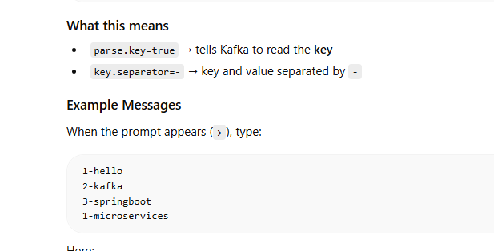
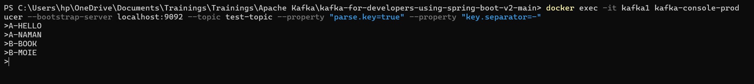
FOR CONSUMER THE COMMAND WILL BE ::
docker exec -it kafka1 kafka-console-consumer --bootstrap-server localhost:9092 --topic test-topic --from-beginning --property print.key=true --property key.separator=-
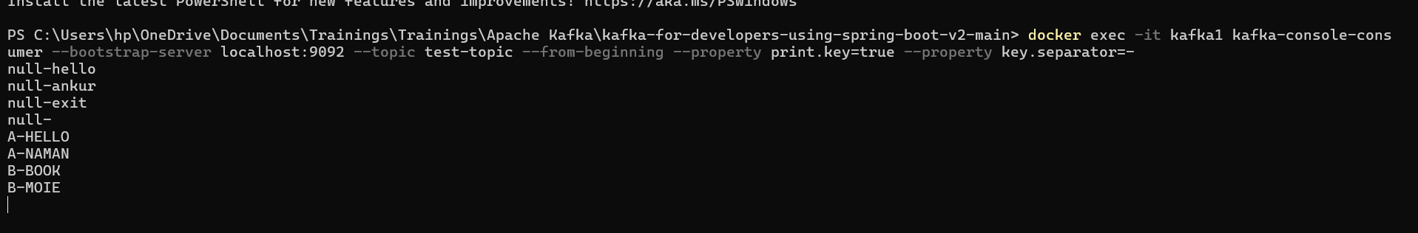
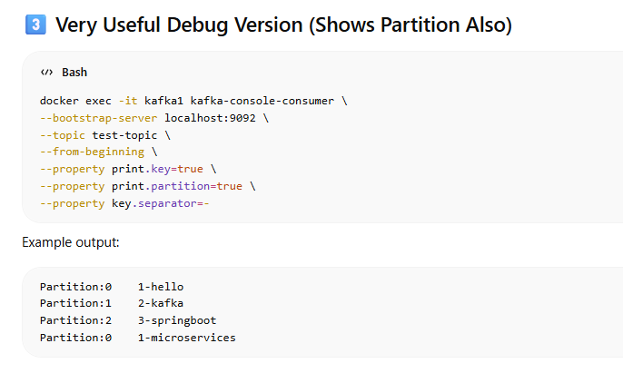
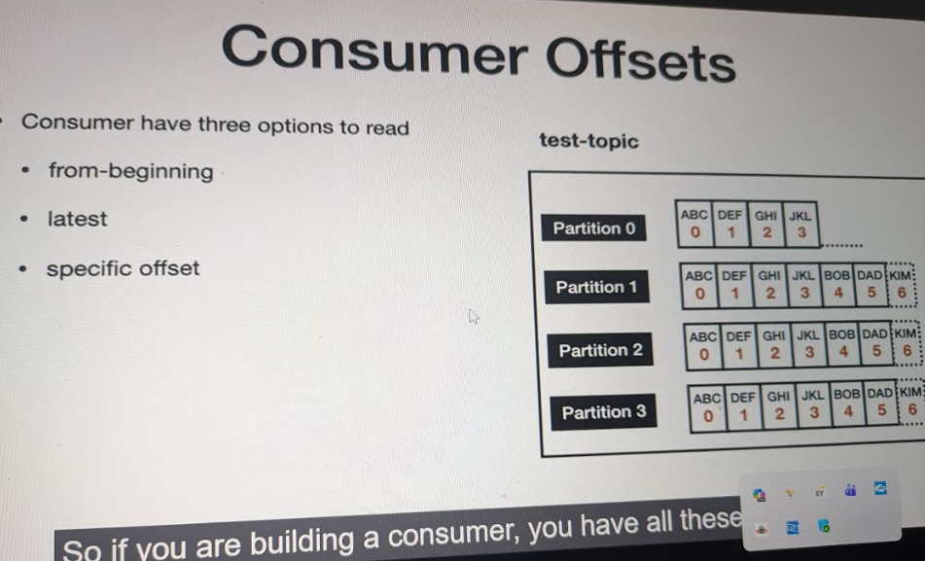
Offset is the unique sequential identifier of a message within a Kafka partition. It represents the position of the message. Consumers use offsets to track which messages they have already processed and where to resume consumption after a restart.
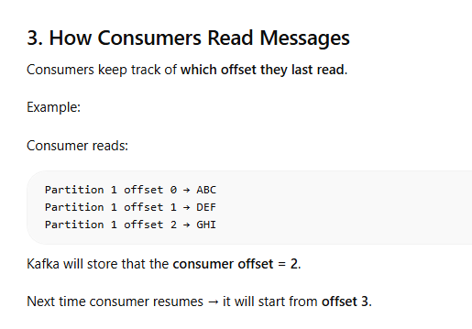
Three Ways Consumers Can Start Reading:
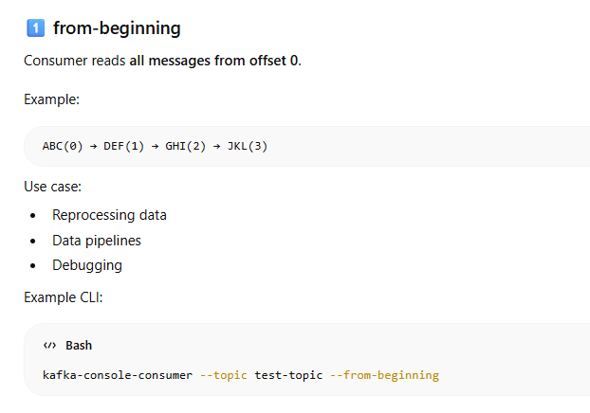
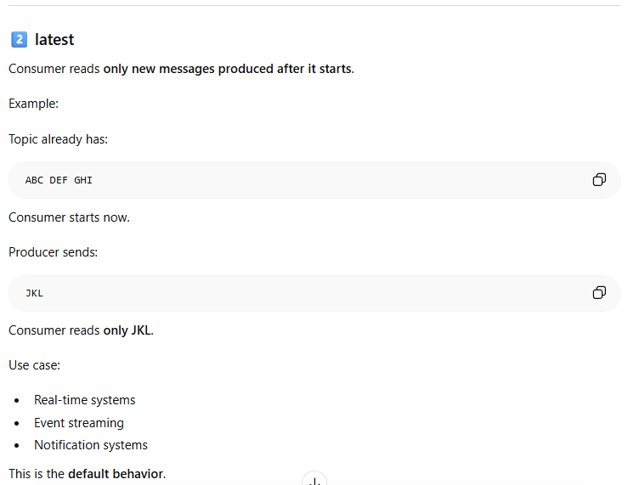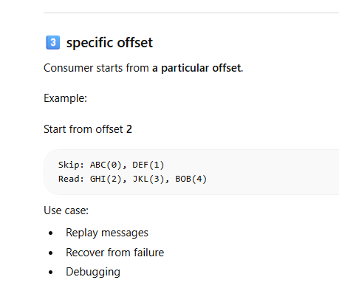
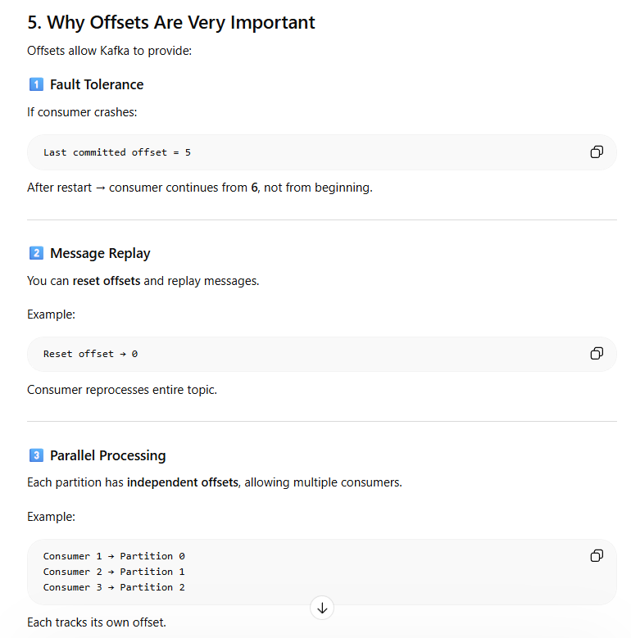
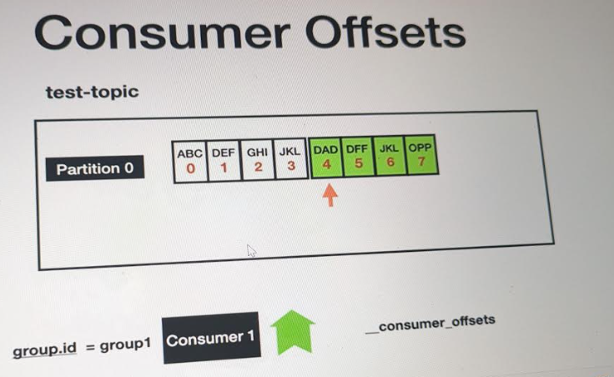
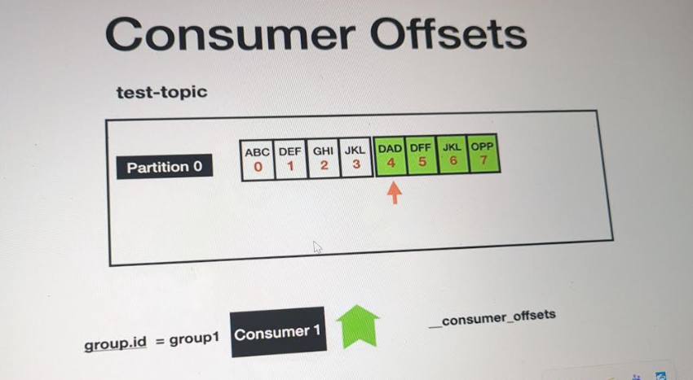
When we read messages from beginning using consumer ::
docker exec -it kafka1 kafka-console-consumer --bootstrap-server kafka1:19092 --topic test-topic --from-beginning
Consumer Group:
A consumer group is a set of consumers that cooperate to consume messages from a Kafka topic, where partitions are distributed among consumers to achieve parallel processing.
Group ID:
The Group ID uniquely identifies a consumer group and allows Kafka to track offsets and manage partition assignments among consumers.
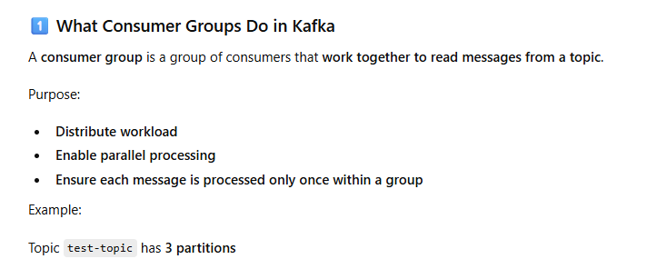
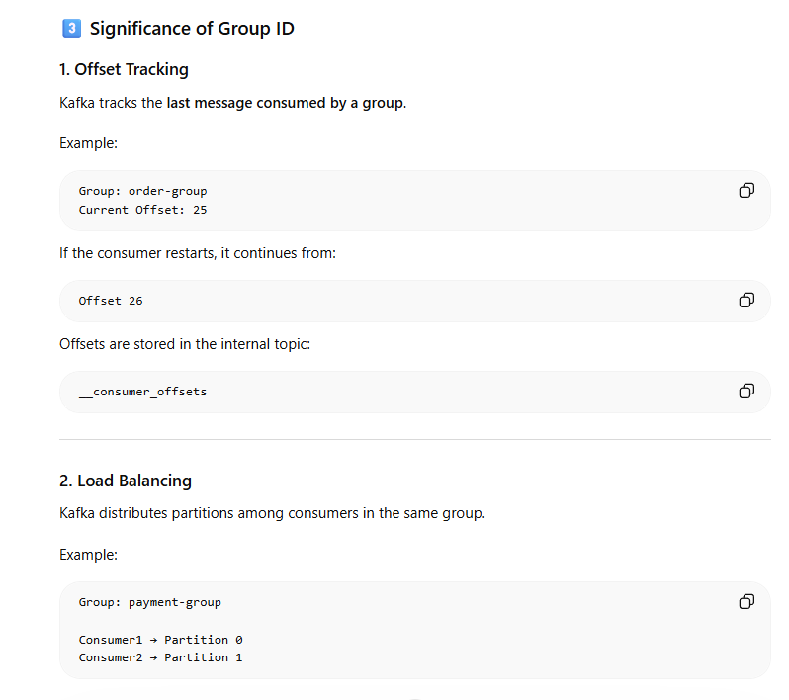
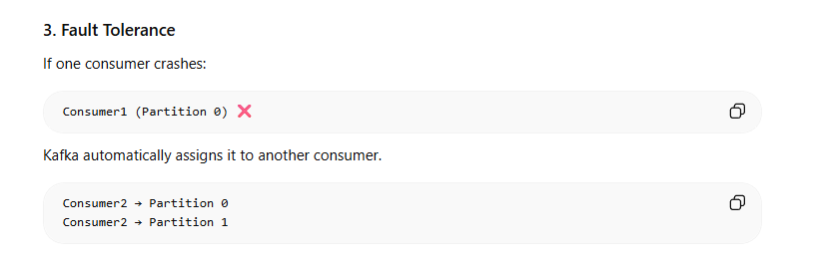
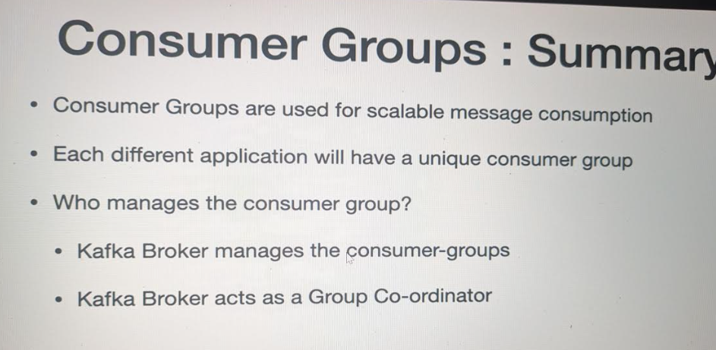
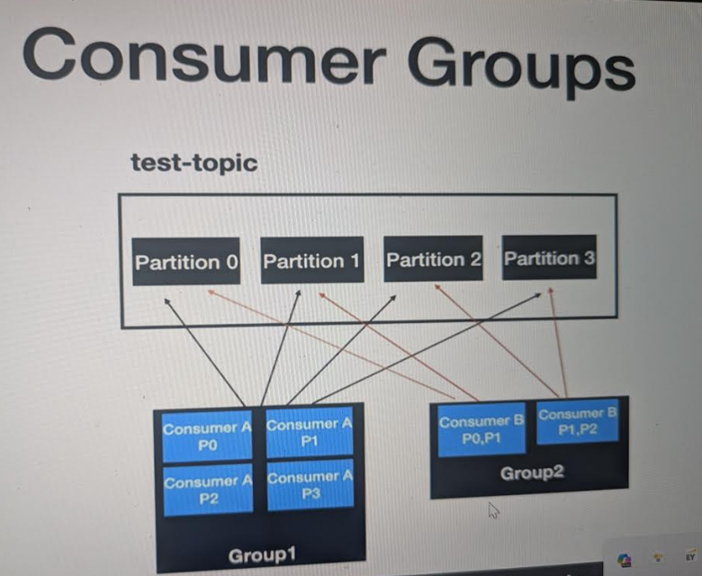
To see the consumer group list command ::
docker exec -it kafka1 kafka-consumer-groups --bootstrap-server kafka1:19092 --list
To see the details of particular consumer group ::
These above groups are temporary group and were lost once the consumer stops.console-consumer
We define our own group such as my-group
Read the message from group
docker exec -it kafka1 kafka-console-consumer --bootstrap-server kafka1:19092 --topic test-topic --group my-group --from-beginning
If you want details include describe ::
docker exec -it kafka1 kafka-consumer-groups --bootstrap-server kafka1:19092 --describe --group my-group
Here my group is treated as group id helps in identifying consumers and until what offset the messages are read from consumer.
To see the list of partitions and describe topic you can use describe with topic:
docker exec -it kafka1 kafka-topics --bootstrap-server kafka1:19092 --describe --topic test-topic
Docker command to increase partitions ::
docker exec -it kafka1 kafka-topics --bootstrap-server kafka1:19092 --alter --topic test-topic --partitions 5
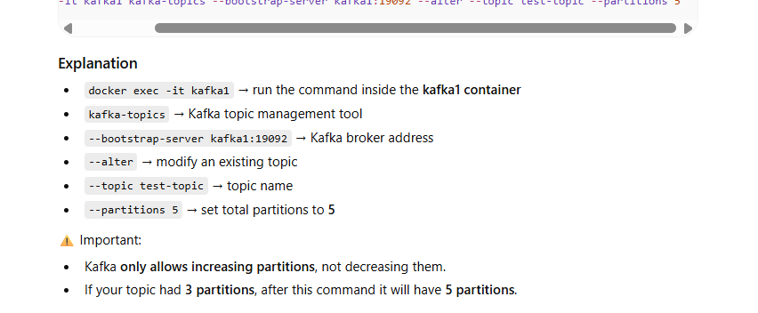
Read the messages from the consumer with a group ID,
For beginning ::
docker exec -it kafka1 kafka-console-consumer `
--bootstrap-server kafka1:19092 `
--topic test-topic `
--group my-group `
--from-beginning `
--property print.key=true `
--property key.separator=" - "
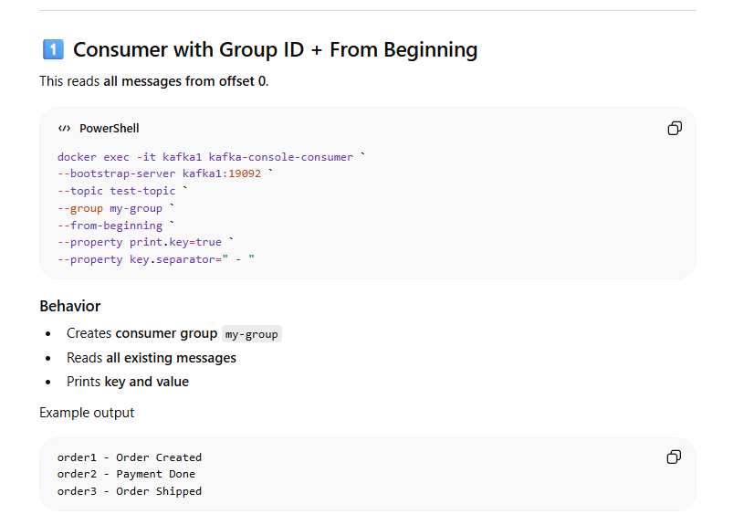
Now we createad a spin or two instances of same consumer My group and then we have produce message so producer will pass the messages to different partitions and group will acquire message from different partition but group id is same in this case.
Provide parallel processing
docker exec -it kafka1 kafka-console-consumer `
--bootstrap-server kafka1:19092 `
--topic test-topic `
--group my-group `
--property print.key=true `
--property key.separator=" - "
One instance capture one message another instance capture another message
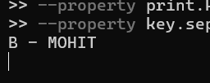 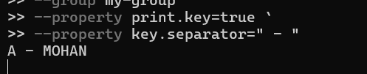
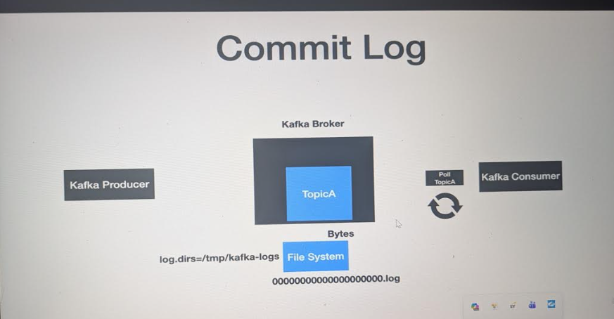
When the Producer sends the messages the broker stores messages in topic and partitions data file are stored in form of Bytes with extension of log .
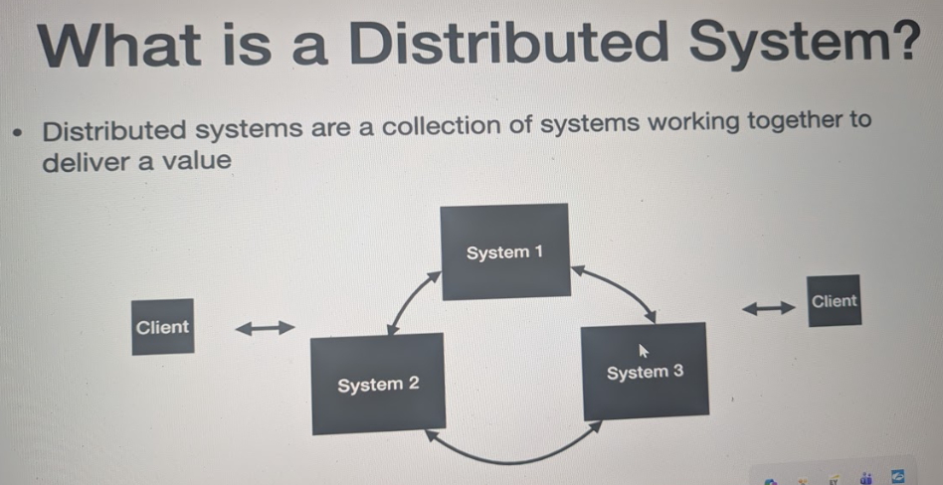
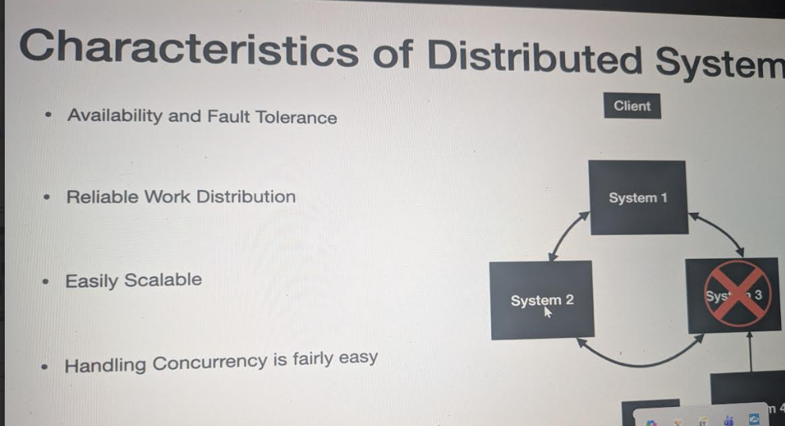
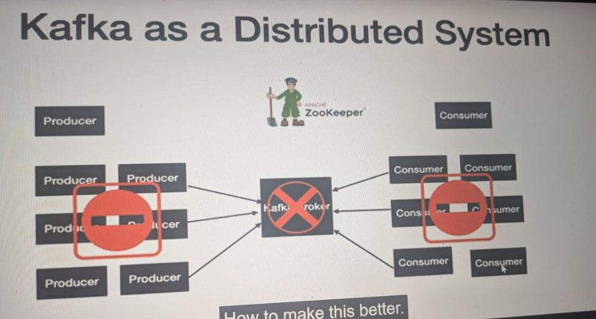
If we single instance of Broker we will have issue of single point failure .
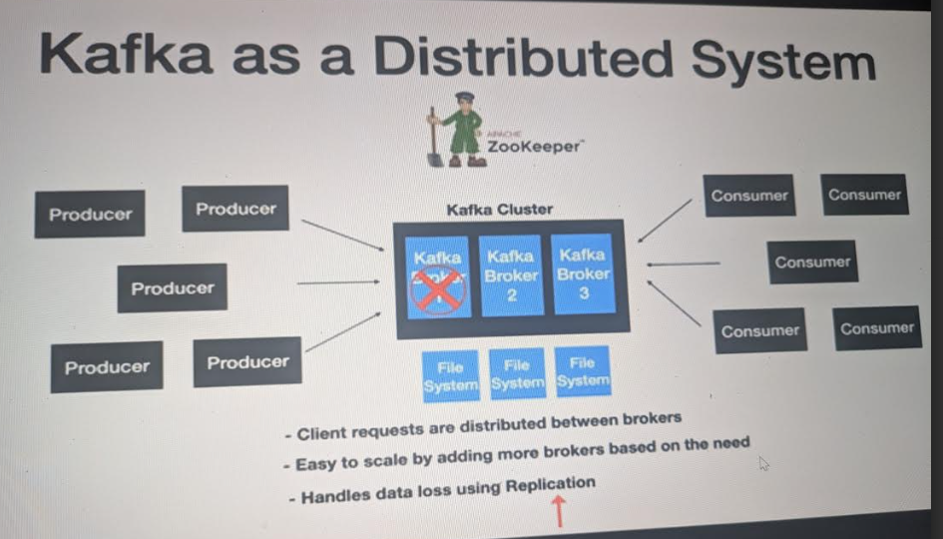
Now we will set up Kafka using 3 brokers ::
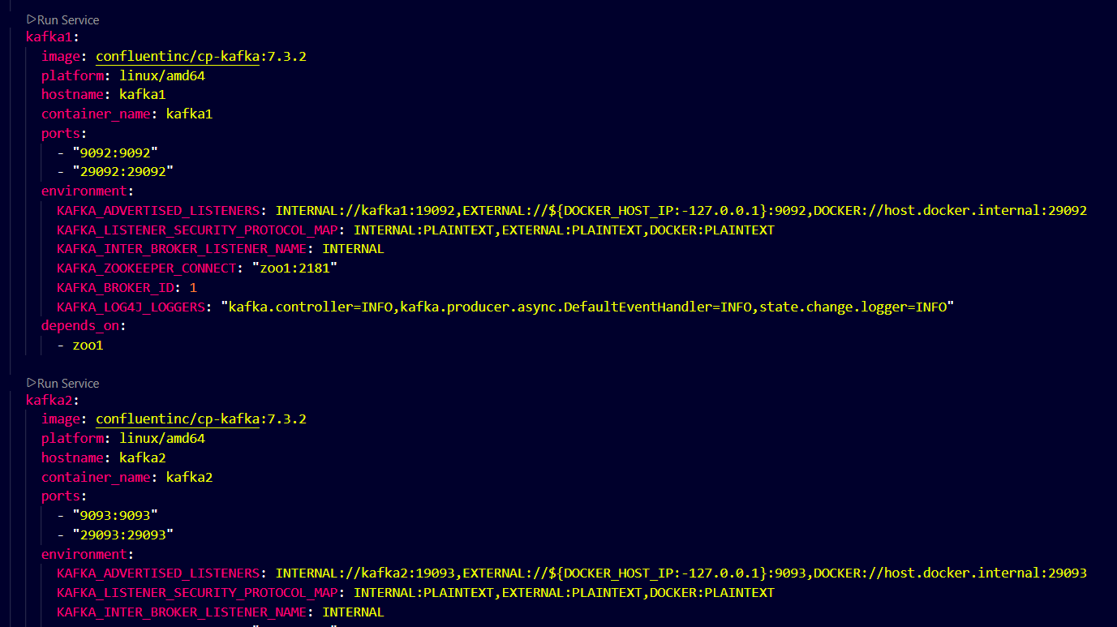
Here we have multi-broker yml file all 3 kafka are dependent upon zookeper 1 zool1 , with 92,93,94
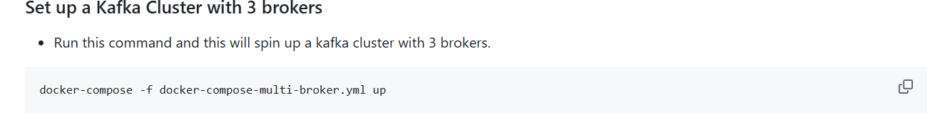
Now we will use this coomand to particulary use multi-broker.yml file
docker-compose -f docker-compose-multi-broker.yml up
This will enable the multi broker up you can see it by using the command docker ps -a
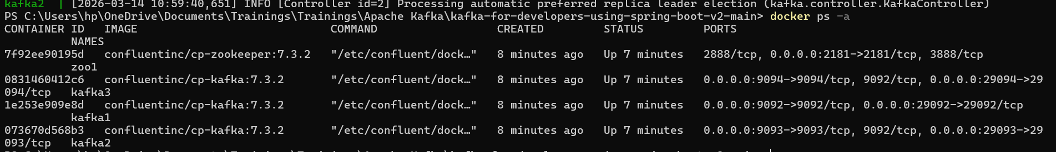
Created Topic ::
This will still distribute partitions across all 3 brokers.
docker exec -it kafka1 kafka-topics --create --topic orders-topic --bootstrap-server kafka1:19092 --partitions 3 --replication-factor 3
You can list all kafka servers to make it more fault tolerant ::
docker exec -it kafka1 kafka-topics --create --topic orders-topic --bootstrap-server kafka1:19092,kafka2:19093,kafka3:19094 --partitions 3 --replication-factor 3
Producer ::
docker exec -it kafka1 kafka-console-producer --topic orders-topic --bootstrap-server kafka1:19092,kafka2:19093,kafka3:19094
Consumer :
docker exec -it kafka1 kafka-console-consumer --topic orders-topic --bootstrap-server kafka1:19092,kafka2:19093,kafka3:19094 --from-beginning:
Producer and consumer first connect to any available broker from the bootstrap server list. That broker returns cluster metadata. If a broker that is a partition leader fails, one of its replicas becomes the new leader and clients automatically continue communicating with it.
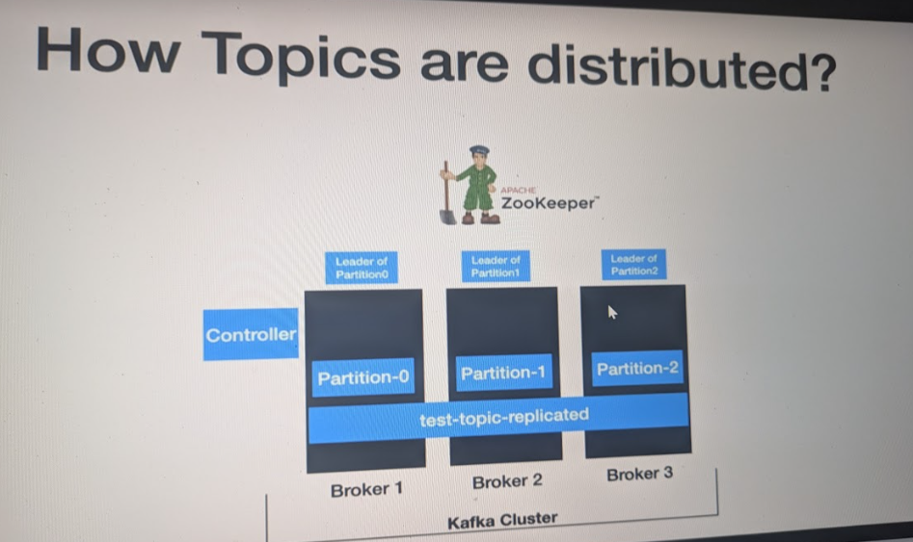
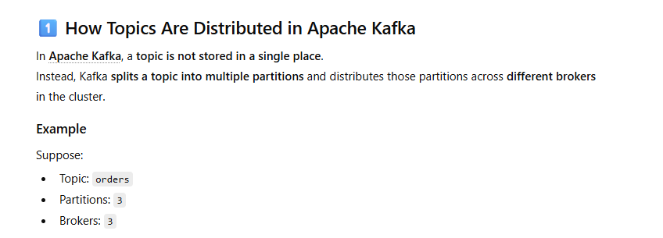
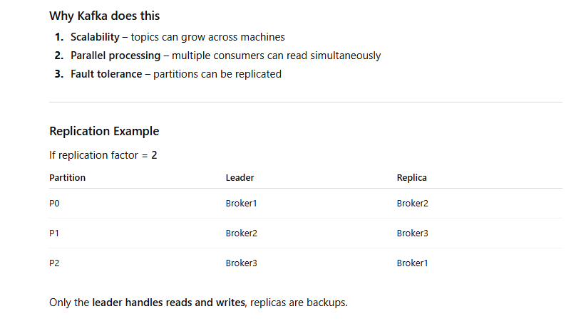
When the topics is created it is distributed into various brokers and partitions
this is known as Leader of partition
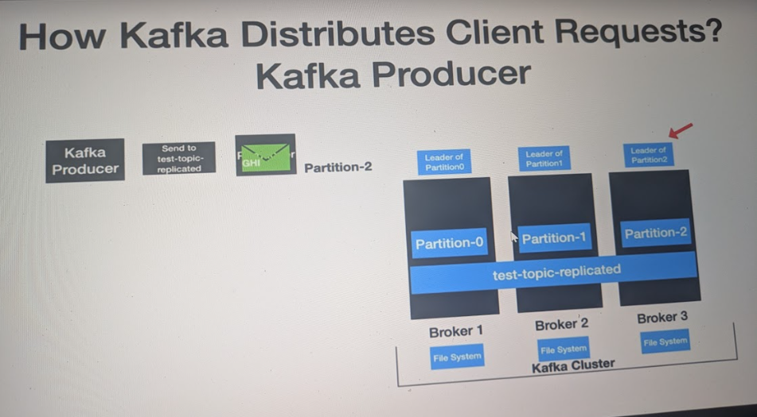
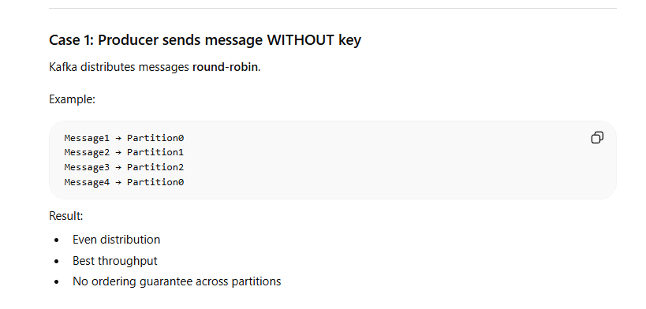
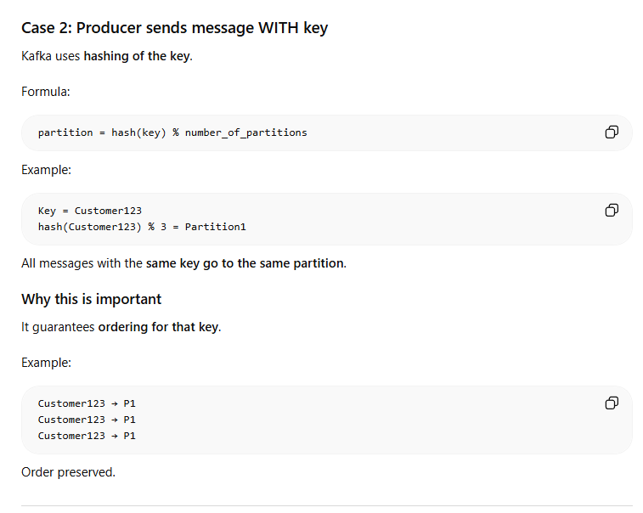
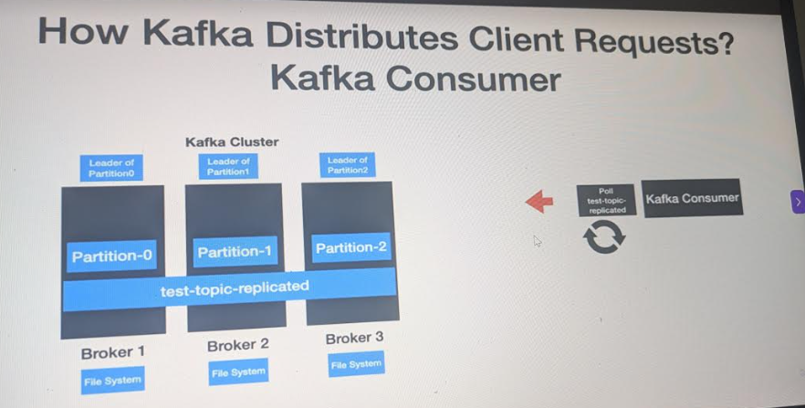
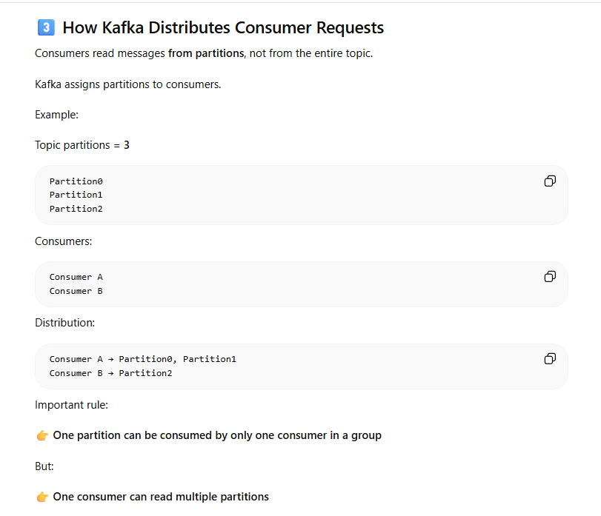
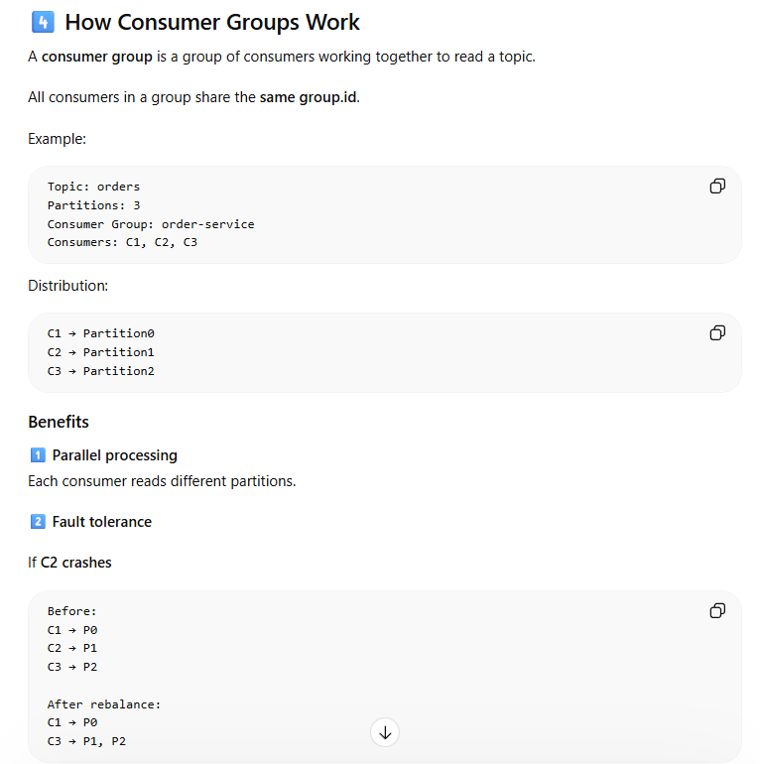
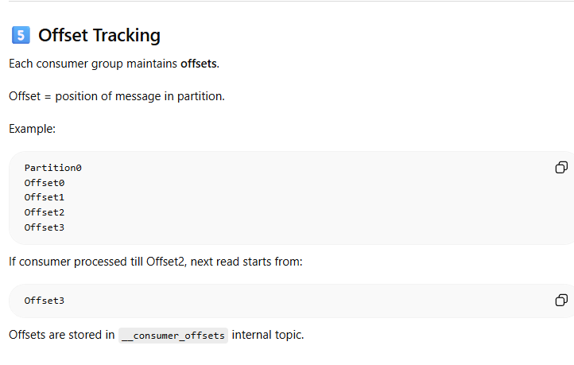
Group id is used to do offset tracking
Kafka distributes data using partitioned topics across brokers, producers send messages to partitions using round-robin or key hashing, and consumer groups parallelly consume partitions with automatic rebalancing and offset tracking.
docker exec -it kafka1 kafka-topics --bootstrap-server localhost:9092 –list
List of Topics ::
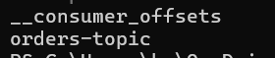
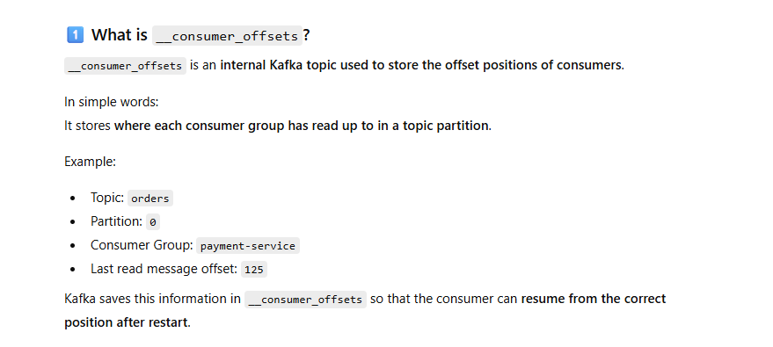
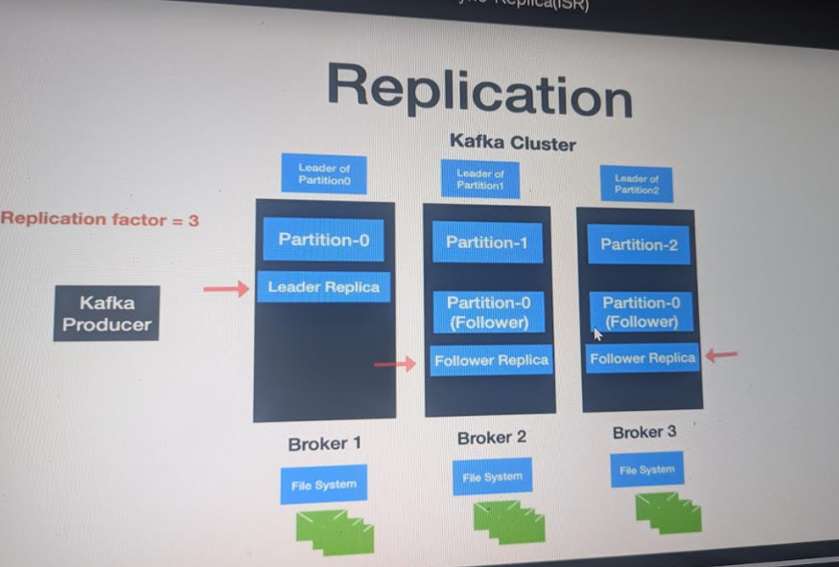
Replication means we replica data between brokers so if one broker fails other can be used .
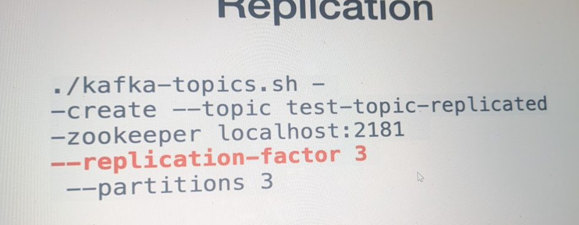
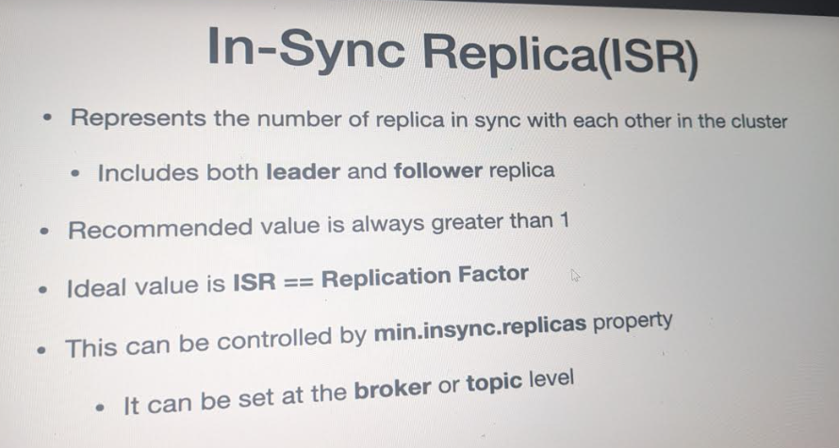
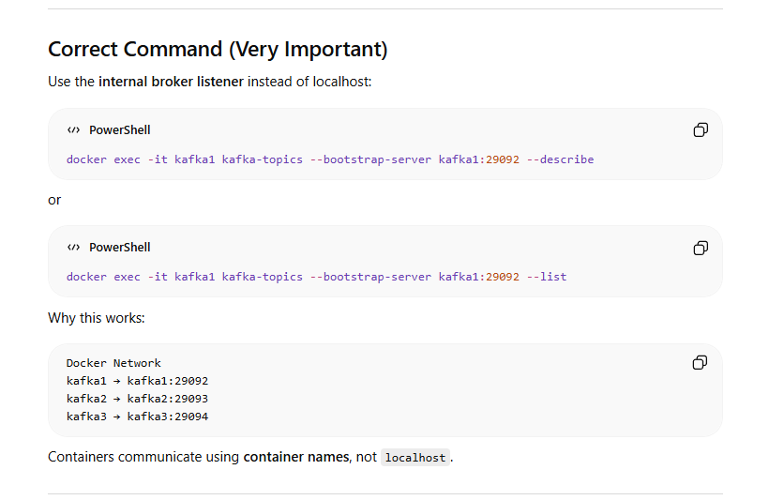
Sometimes describe not work with localhost.
To stop Mutliple broker :: instead of docker-compose down specify multi broker file name
docker-compose -f docker-compose-multi-broker.yml down
or docker-compose down --remove-orphans (will remove all)
To stop or start any broker ::
containerId :: can be copied from docker ps -a
docker stop containerId
docker start containerId
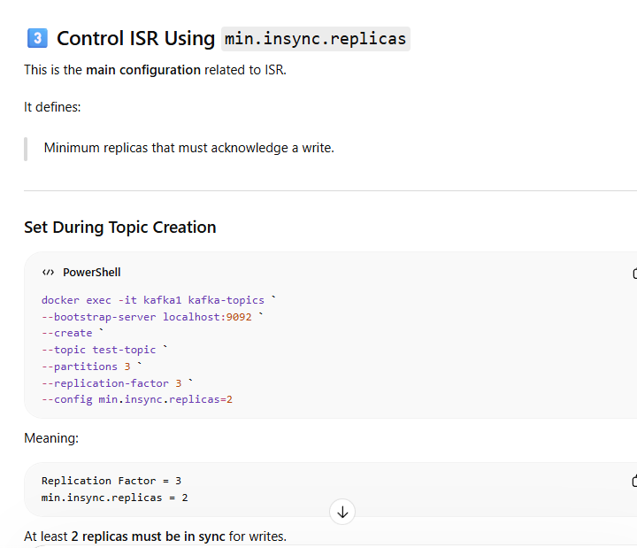
Kafka Producer Configurations ::
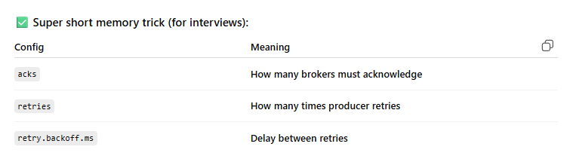
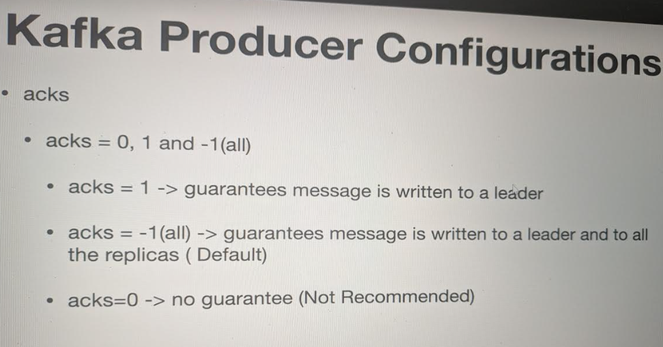
By default value is -1 Most Recommended .
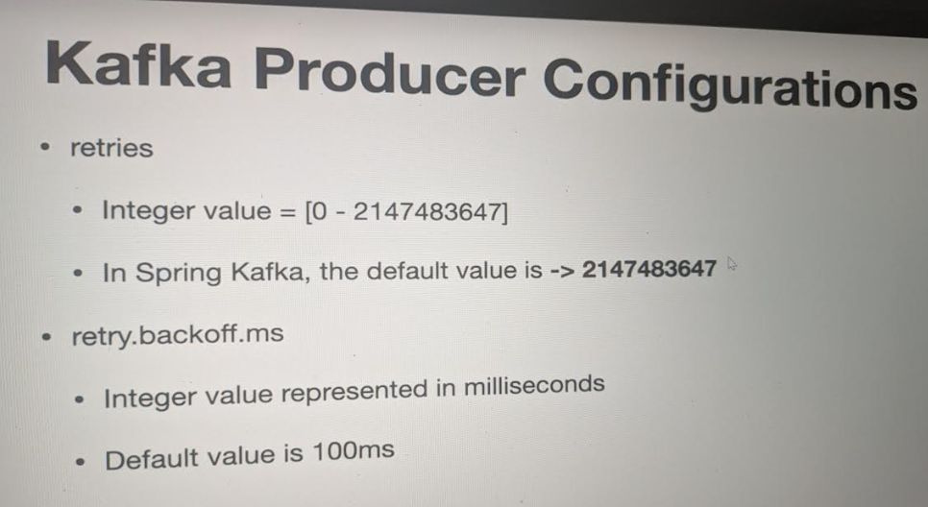
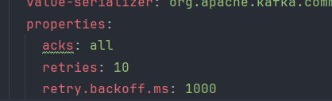
In yml file you can oveeride properties::
Kafka Consumer Configuration ::
